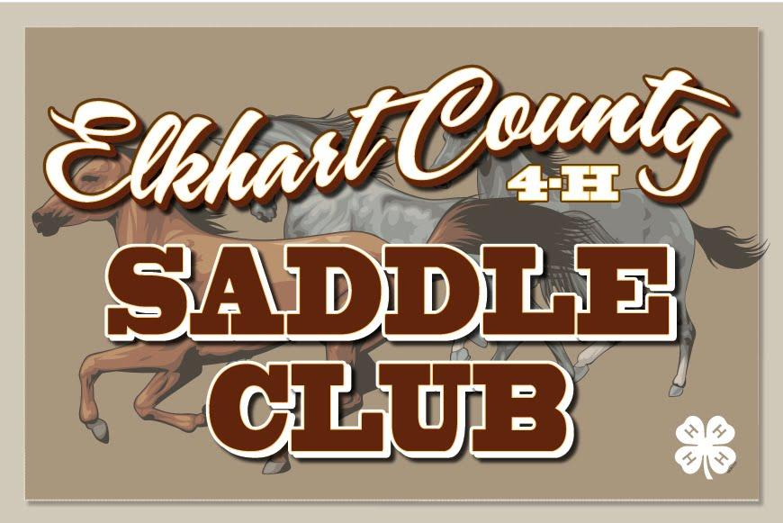
Elkhart County 4-H Saddle Club – Meeting Agenda for February 14th, 2022
- 6:30 New Members /Family Meeting (Heather Riegsecker)
  - Binders for 1st year members distributed (includes: survival guide, Horse & Pony Handbook)
- 7:00 meeting brought to order – President, Ethan Barkey
  - Pledges –
  - Minutes – Tiffanie Double
  - Health & Safety – Dani Herschberger; TOPIC: Dewormer
- Installation of Remaining Officers – Ashley Holdeman
- Introduction of Leadership: (*p. 3-4) learn the faces that go with the names!! – Ethan Barkey
  - Leaders:
    - Ashley Holdeman - Organizational Leader
    - Sierra Cross – Junior Leader Coordinator & Project Leader
    - Heather McKay - Educational Leader
    - Heather Riegsecker – 1st & 2nd Year Member Leader
  - Advisory Board:
    - President – Michelle Cross; Vice President – Andy Yeager; Secretary – Steph Guild; Treasurer – Kristal Cutter; Members – Dawn Setser, Heather Riegsecker, Doug McKay, JD Double, Eric Ellsworth
- Vote for our 2022 Fair Queen Representative
- Take Club Picture
- Old Business:
  - 2021 Completion Pins and Awards are available at the Completion Pin table
  - Adult Volunteers must sign up with Ashley to get the application process started – Ashley Holdeman
- New Business:
  - Treasurer’s Report – Kristal Cutter
  - T-Shirts – Orders accepted at monthly meetings. Two styles available; $15 each - Dawn Setser
  - Forms - Survival Guide, Project Leaders, Vaccinations, etc. (all available on website) – Ashley Holdeman
  - Fair Week Camping Spot list (*p. 16) - Andy Yeager
  - Midstates Team update and information – Jen Cripe
  - Drill Team Call Out – Allie Miller
  - Tack Sale at April meeting – Set up at 4:30 PM; open to sell at 5:00 PM. You will need to monitor your own table and collect your own money. You CANNOT close your table until at least 30 minutes after the club meeting ends!!!!
  - Open Shows - Club open show dates are listed in the survival guide; show bills posted on the club website as well as patterns
  - Clinics – Specifics (dates, times and locations) TBA – Andrea Yeager, Chelsea Yoder
    - April – English Pleasure (with invitation to a jumping clinic offsite for our members)
    - May - Barrels
    - June – Western Pleasure
  - Club Dues (*p. 7 )- $45 for first family member – further details in survival guide – Michelle Cross
  - Work Shifts (*p. 11-12) – requirements for 2022; sign-ups start at March Meeting – Michelle Cross
  - FUNDRAISER – Detergent Sales will start at the February Meeting – Jen Meyer
    - WE WILL NOT BE HAVING A FALL DETERGENT FUNDRAISER!!!!! PLEASE PLAN ACCORDINGLY!!!!!
  - Leases (*p. 7) – If you need a horse to lease for the year, or if you have a horse available – Jen Meyer
  - Essays – You can start submitting in March; Topic – History of Horse Breeds; DUE BY JUNE 15th; – Ashley Holdeman

- Meeting Topic: Horse Maintenance - Feed, Vaccines and Deworming
  - ACTIVITY: Create a deworming and farrier schedule

- What You Need to Know and Do Tonight:
  - Adult Volunteers – please make sure you have enrolled online and completed the safety training videos (now due every year). Please see the enrollment table to check and see if anything is missing.

- Items to pick up or receive at tonight’s meeting:
  - 2022 Survival Guide
  - 2020 Horse and Pony Handbook
    - This is the same version offered last year. If you have already picked one up, please do not take another. The club provides one per family.
  - Completion Pins/Awards as needed
  - First Year families – binders

- Do Online:
  - Find our website: www.elkhartcounty4hsaddleclub.com
  - Find us on Facebook!! Elkhart County Saddle Club
  - Text Alerts: Text your name and ‘join2022’ to 574-370-6421 to be added

- 4-H Member Sign-Up Opportunities
  - Midstates
  - Drill Team

- Next Month:
  - Meeting on Monday, March 14th, 2022 at Ag Hall
    - 6:30 1st & 2nd Year members/families
    - 7:00 Club Meeting
  - Detergent fundraiser due
  - T-Shirt orders taken

