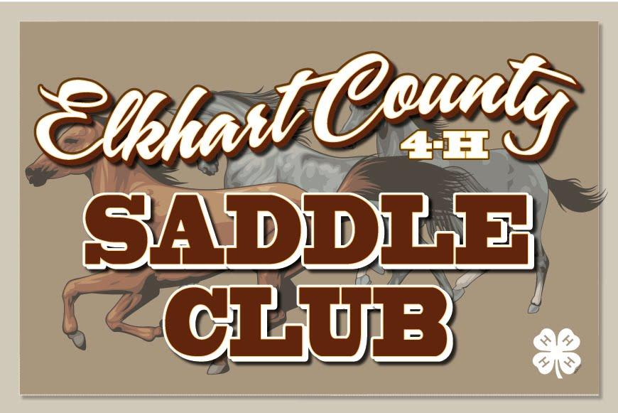
Elkhart County 4-H Saddle Club – Meeting Agenda for March 14th, 2022
- 6:30 New Members /Family Meeting (Heather Riegsecker)
  - Horse Camp (*p. 16) Dates: June 19-22; we are now accepting camper applications for 1st-3rd year members wishing to attend camp; Camp Jr. Leaders accepted for 9th-12^{thn} graders and gopher applications for 6th-8th graders; Adult Leaders are needed in many areas too!!! All applications due at April Meeting!!!! – Jen Cripe
- 7:00 meeting brought to order – President, Ethan Barkey
  - Pledges –
  - Minutes – Tiffanie Double
  - Health & Safety – Dani Herschberger; TOPIC: _______
- Old Business:
  - Essay Topic: History of Horse Breeds; you can turn these in starting tonight; DUE JUNE 15TH!!!!
  - Costume Class Theme: Superheroes
  - 2021 Completion Pins and Awards are available at the Completion Pin table.
  - Tack Sale at April meeting – Set up at 4:30 PM; open to sell at 5:00 PM. You will need to monitor your own table and collect your own money. You CANNOT close your table until at least 30 minutes after the club meeting ends!!!! –Ashley Holdeman
  - Open Shows - These dates are listed in the survival guide; show bills are posted on the club website as well as patterns for the pleasure classes. Contesting patterns are in your Horse & Pony Handbook.
  - Leases (*p. 7) – Need a horse to lease for the year, or if you have a horse available - see Leases table
  - Clinics: English – April 3rd; Jumping - April 10; Barrels – May 14th; Western Performance – June 4th. English Clinic information available with Chelsea. – Andrea Yeager/Chelsea Yoder
  - Work Shifts (*p. 11-12) Sign-ups begin tonight at the meeting and will be open online after - Michelle
- New Business:
  - 2022 4-H Fair Queen Representative is Ms. Tiffanie Double
  - Horse Enrollments - now available online through MAY 15th!!! This is a state deadline!! If you miss this deadline, you will need to complete a poster, as we are not able to enroll horses after May 15th!!!!
    - Please sign up ALL horses you have access to as a backup. Horses not signed up are ineligible to be shown at fair.
    - If you do not have a backup and you are unable to show a horse at fair for whatever reason, you MUST complete a poster in order to complete your project!! – Ashley H.
  - FUNDRAISER – Detergent orders due tonight!!! Money due tonight. Pick-up, on April 19th time TBA; Geraniums begin tonight – Jen Meyer
  - Vaccinations (*p. 7) – offered at our barn Wednesday, March 16th and Tuesday, April 12th at 5:30. Please See Karin at the Vaccination table to sign up tonight!! You MUST have these completed to turn in on May 15th. If your vet will not sign the form we have, a copy of your receipt showing payment is required. The cost is $___/horse for all required vaccines; $___/horse to add West Nile to required vaccines.
    - You must sign up with your phone number and the # of horses you wish to have vaccinated ahead of the date of vaccination clinic!! – Karin Senn
  - Fair Packet Pick Up Night – July 11th; NEW THIS YEAR: You must complete all required steps, as in the past, but you must also complete a task cleaning up the grounds. More information TBA
  - 10 Year and Retiring Members – please see Michelle Hart for all information to successfully complete your final year and for your jacket fitting, which needs to be completed by MAY 15th!! – Michelle Hart

- Meeting Topic: PROPER TACK AND ATTIRE DEMONSTRATIONS

- Items to pick up or receive at tonight’s meeting:
  - 2020 Horse and Pony Handbook
    - This is the same version offered last year. If you have already picked one up, please do not take another. The club provides one per family.
  - Completion Pins/Awards as needed
  - Horse Camp Camper Applications
  - Horse Camp Junior Leader Applications
  - Vaccination Forms
  - Lease Agreements

- Do Online:
  - Find our website: www.elkhartcounty4hsaddleclub.com
  - Find us on Facebook!! Elkhart County Saddle Club
  - Text Alerts: Text your name and ‘join2022’ to 574-370-6421 to be added

- 4-H Member Sign-Up Opportunities
  - Midstates
  - Drill Team
  - Horse Camp

- Next Month:
  - Meeting on Monday, April 11th, 2022 at the Sheep Swine Arena
    - 6:30 1st & 2nd Year members/families
    - 7:00 Club Meeting
    - TACK SALE – from 5:00 PM to 30 minutes after meeting is adjourned
  - Geranium fundraiser due
  - Pork Burger Fundraiser Kickoff
  - Vaccination Clinic – Tuesday, April 12th, Saddle Club Barn @ 5:30 PM
  - T-Shirt orders taken

