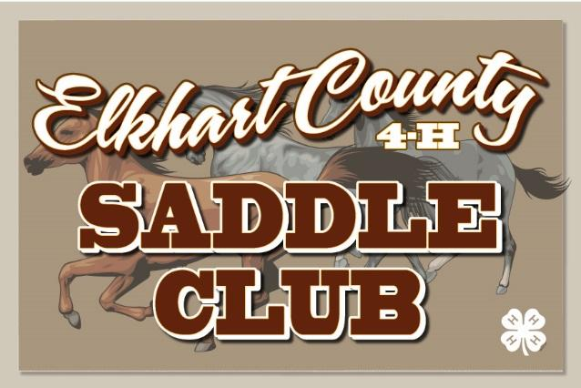

Application For Horse Camp June 21-24, 2020

Name of 4-H Member: ____________________________________
T-Shirt Size: YS (6-8) YM (10-12) YL (14-16) AXS AS AM AL AXL AXXL
Address: _____________________________________________________________________
Gender: M / F Age: __________ Year(s) In Saddle Club: _______________
Parent / Legal Guardian Name: _____________________________ Phone: ______________
Address: _____________________________________________________________________
Employer: ____________________________________ Work Phone: _________________
In Case of Emergency (if parent / guardian not available): ______________________________
Phone: __________________ Employer: ____________________ Phone: ___________

Medical Information

Family Physician: _______________________________ Phone: _________________
Are You Allergic to anything? (if so explain) _________________________________________
Are You Taking Any Medication? Yes / No If yes, please explain: ________________________
______________________________________________________________________________

Horse Information

Horse Name: ______________________________________________ Age: ____________
Breed: ________________________ Gender: _________________________
Name of Veterinarian: ____________________________________ Phone: ________________
Address: ______________________________________________________________________
Does Your Horse Have Any Habits Or Issues The Camp Director Needs To Know? __________
_____________________________________________________________________________
Riding Style (check all that is supply): ____Western _____ English _____Speed ______ Trail
I desire to attend the Elkhart County 4-H Saddle Club Horse Camp. I agree to abide by the rules of the camp. Enclosed is my non-refundable check for $50.00, made out to Elkhart County 4-H Saddle Club.

Member Signature: __________________________________ Date: _________________
Parent / Legal Guardian: ______________________________ Date: _________________

Consent To Medical Treatment
Elkhart County 4-H Saddle Club
Goshen, IN

The undersigned, being a parent (guardian) of _______________________________________________
(name of child)

a minor child, and having read the attached regulations and information regarding Elkhart County 4-H Saddle Club Horse Camp do hereby freely and voluntarily, without any coercion or duress whatsoever, give my consent and authorization as follows:
- Any 4-H Saddle Club leader or Board Member is hereby constituted to be my lawful agent and attorney-in-fact for the purpose of signing any all medical authorizations for medical and/or surgical treatment and/or special procedures (including by way of illustration and not limitation, administration of anesthesia, blood transfusions, diagnostic test, etc.) for my child which may be required during our absence. I agree the decision may be solely upon the judgment of the 4-H Saddle Club leaders and/or Board Member should any emergency situation exist.
- I agree to be responsible for all costs incurred as the result of any medical or emergency treatment administered.
Please note any medications or treatment, which should not be administered to this child. (If none please state that on the line provided). _____________________________________________________________________________________
_____________________________________________________________________________________
Please state any hidden medical conditions such as heart disease, diabetes, epilepsy, etc. This information is strictly for the use of trained emergency personnel in case of an emergency.
_____________________________________________________________________________________
_____________________________________________________________________________________

Parent / Legal Guardian: ________________________________________________________________
Date: ______________________________

